**Excecise1;**

**Scenario 1**

begin

    for cus in(SELECT CUSTOMERID,DOB from CUSTOMERS )LOOP

        IF Months_Between(SYSDATE,cus.DOB)/12< 60 THEN

            UPDATE LOANS

             Set INTERESTRATE=INTERESTRATE-1

            WHERE CUSTOMERID = cus.CUSTOMERID;

            DBMS_OUTPUT.PUT_LINE('Updated interest rate for CustomerID: ' || cus.CustomerID);

        end if;

     end LOOP;

end;

/

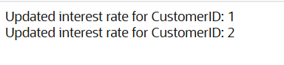**Output**

**Scenario 2**

alter table Customers add IsVIP VARCHAR2(5);

BEGIN

    for cus in(SELECT BALANCE,CUSTOMERID from CUSTOMERS)LOOP

    if cus.BALANCE>10000 THEN

    UPDATE  CUSTOMERS set ISVIP="TRUE"

    where cus.CUSTOMERID=CUSTOMERID;

    end if;

    end loop;

    end;

    /

**OUTPUT**

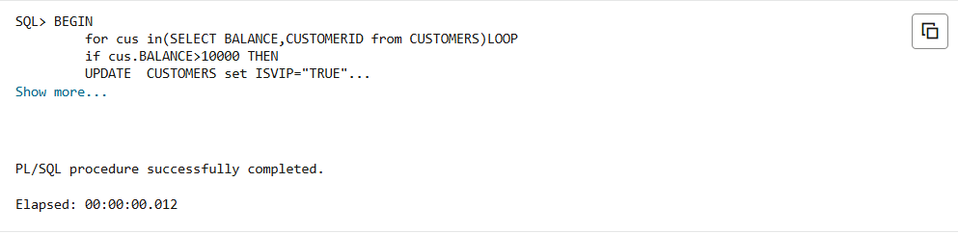

**Scenario 3**

declare

var_name varchar(50);

BEGIN

    for loan in(select LOANID,CUSTOMERID,ENDDATE from LOANS where ENDDATE between sysdate and sysdate+30)LOOP

    Select NAME into var_name from CUSTOMERS where CUSTOMERID=loan.CUSTOMERID;

    DBMS_OUTPUT.PUT_LINE(loan.LOANID || chr(10) ||var_name||chr(10)|| loan.ENDDATE);

    END loop;

    END;

    /

**OUTPUT**

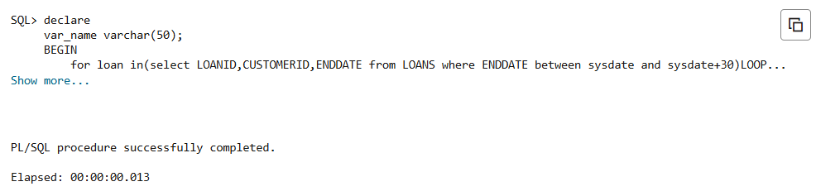

**EXERCISE 2**

**Scenario 1**

create or replace PROCEDURE transfermoney(

    person_from_accountid in NUMBER,

    person_to_accountid in number,

    amount in NUMBER

)as v_balance Number ;

begin

    SELECT Balance into v_balance from ACCOUNTS

    where ACCOUNTID=person_from_accountid ;

    if v_balance<amount then

        Raise_application_error(-20001,'Insufficient funds');

    end if;

    update ACCOUNTS set

    BALANCE =balance-amount

    where ACCOUNTID=person_from_accountid;

    update ACCOUNTS set

    BALANCE=BALANCE+amount

    where ACCOUNTID=person_to_accountid;

    COMMIT;

EXCEPTION

    when others THEN

    dbms_output.PUT_LINE('Transation failed'|| sqlerrm);

end;

/

**OUTPUT**

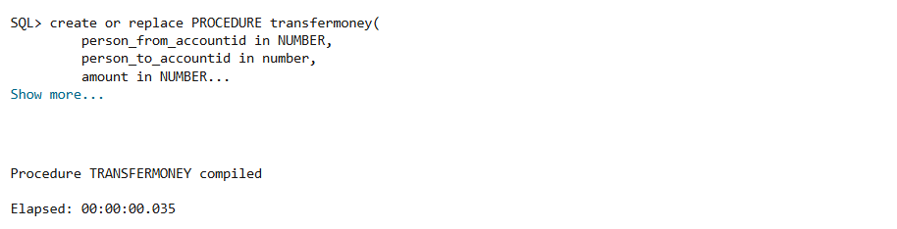

**Scenario 2**

CREATE OR REPLACE UpdateSalery(

    person_emloyeeid in number,

    percentage in number

)as

begin

    update employees set

    salary=salary+(salary*percentage/100)

    where EmployeeId=person_emloyeeid;

    if sql%rowcount=0 then

      dbms_output.put_line('no employee found');

    end if;

exception

WHEN OTHERS THEN

DBMS_OUTPUT.PUT_LINE(SQLERRM);

END;

/

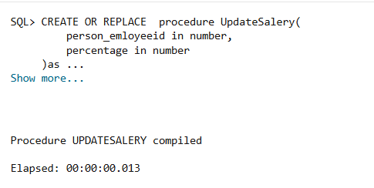**OUTPUT**

**Scenario 3**

create or replace procedure addnewcustomer(

    person_customerid in number,

    person_name in VARCHAR,

    person_dob in date,

    person_balance in number

)as

begin

    INSERT into CUSTOMERS(CUSTOMERID,NAME,DOB,BALANCE,LASTMODIFIED)

    VALUES(person_customerid,person_name,person_dob,person_balance,sysdate);

EXCEPTION

when dup_val_on_index THEN

dbms_output.put_line('customer id already exists');

when others then

dbms_output.PUT_LINE(sqlerrm);

end;

/

**OUTPUT**

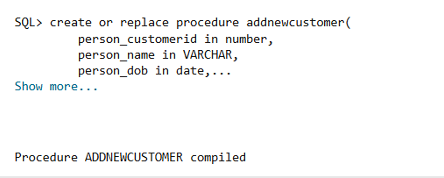

**EXERCISE 3**

**SCENARIO 1**

create or replace procedure proceessMonthlyintrest as updated_rows number:=0;

begin update ACCOUNTS set

BALANCE=BALANCE*1.01

where ACCOUNTTYPE='Savings';

updated_rows:=sql%rowcount;

dbms_output.PUT_LINE(updated_rows ||'have been updated');

EXCEPTION

when others then

    dbms_output.put_line(sqlerrm);

end;

/

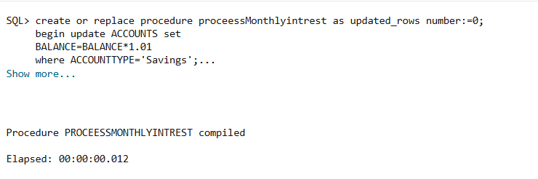**OUTPUT:**

**SCENARIO 2**

create or replace PROCEDURE updateEnployeeBonus(

    department in VARCHAR,

    bonus in NUMBER

)as NO_ROWS NUMBER :=0;

BEGIN

    update EMPLOYEES set

    SALARY=SALARY+(salary*bonus/100)

    where DEPARTMENT=department;

    NO_ROWS:=sql%rowcount;

    if NO_ROWS =0 THEN

    dbms_output.put_line('no records found');

    ELSE

    dbms_output.PUT_LINE(No_ROWS || ' have been updated with a bonus of'||bonus);

    end if;

EXCEPTION

    when others THEN

    dbms_output.put_line(sqlerrm);

end;

/

**OUTPUT**

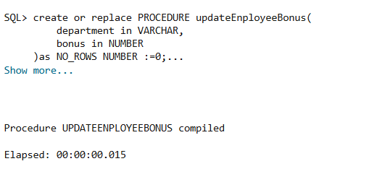

**SCENARIO 3**

create or replace PROCEDURE TransferFunds (

    person_from_accountid in NUMBER,

    person_to_accountid in number,

    amount in NUMBER

)as v_balance Number ;

begin

    SELECT Balance into v_balance from ACCOUNTS

    where ACCOUNTID=person_from_accountid ;

    if v_balance<amount then

        Raise_application_error(-20001,'Insufficient funds');

    end if;

    update ACCOUNTS set

    BALANCE =balance-amount

    where ACCOUNTID=person_from_accountid;

    update ACCOUNTS set

    BALANCE=BALANCE+amount

    where ACCOUNTID=person_to_accountid;

    COMMIT;

EXCEPTION

    when others THEN

    dbms_output.PUT_LINE('Transation failed'|| sqlerrm);

end;

/

**OUTPUT**

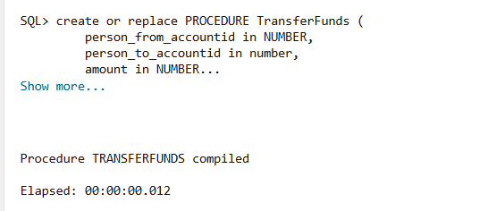

**EXERCISE 4**

**SCENARIO 1**

create or replace FUNCTION calculateage(dob in DATE) return NUMBER is

begin

    RETURN floor(MONTHS_BETWEEN(sysdate,dob)/12);

end;

/

DECLARE

age number;

BEGIN

    age:=CALCULATEAGE(TO_DATE('2005-03-28','YYYY-MM-DD'));

    dbms_output.put_line('age  ' ||age);

end;

/

**OUTPUT**

**SCENARIO 2**

create or replace function cacluatemmonthlyinstallments(

    amount in number,

    rate in number,

    years in number

) RETURN number is

rate_monthly number:=rate /(12*100);

total_months number :=years*12;

begin

    RETURN(amount*rate_monthly*power(1+rate_monthly,total_months)/power(1+rate_monthly,total_months)-1);

end;

/

DECLARE

 emi number;

begin

    emi:=CACLUATEMMONTHLYINSTALLMENTS(10000,10,3);

    dbms_output.put_line('EMI'  || emi);

end;

/

**OUTPUT**

**SCENARIO 3**

create or replace function has_sufficient_balance(

    person_accountid in number,

    person_amount in number

)RETURN boolean is T_balance number;

begin

    SELECT Balance into T_balance from ACCOUNTS where ACCOUNTID=person_accountid;

    return T_balance >person_amount;

EXCEPTION

    when no_data_found then

    return false;

end;

/

declare

  a BOOLEAN;

BEGIN

    a:=HAS_SUFFICIENT_BALANCE(1,100);

    dbms_output.put_line('has sufficient balance for tansaction '|| case when a then chr(10)|| ' true ' else chr(10)|| 'false' end );

end;

/

**OUTPUT**

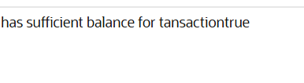

**EXERCISE 5**

**SCENARIO 1**

create or replace trigger updatecustomerlastmodified before update on customers

for each row

begin

    :new.lastmodified:=sysdate;

end ;

/

**OUTPUT**

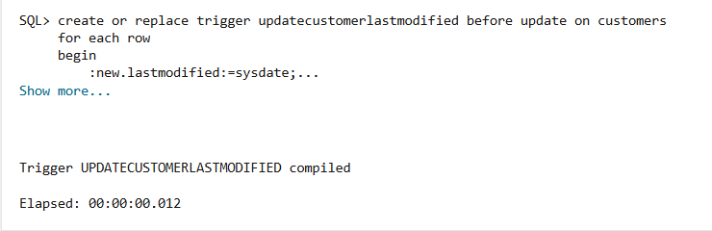

**SCENARIO 2**

**AUDIT TABLE**

CREATE TABLE AuditLog (

  LogID NUMBER GENERATED BY DEFAULT ON NULL AS IDENTITY,

  TransactionID NUMBER,

  AccountID NUMBER,

  ActionType VARCHAR2(20),

  LogDate DATE

);

create or replace TRIGGER logtransaction after insert on transactions

for each ROW

begin

    insert into AUDITLOG(TRANSACTIONID,ACCOUNTID,ACTIONTYPE,LOGDATE)values (101,1568678,'savings',sysdate);

end;

/

**OUTPUT**

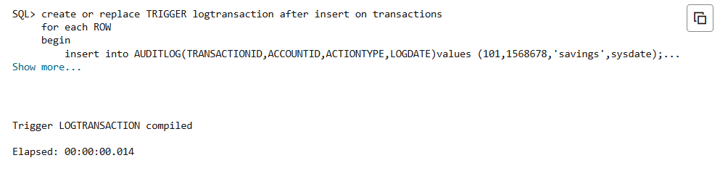

**SCENARIO 3**

create or replace trigger checktansactions before insert on Transactions for each row

DECLARE

account_balance number;

BEGIN

    SELECT balance into account_balance FROM accounts

    WHERE ACCOUNTID = :new.ACCOUNTID

    for update;

    if :new.transactiontype ='withdrawal' and :new.amount>account_balance then

    dbms_output.PUT_LINE('Insufficient balance');

    elsif :new.transactiontype ='deposit' and :new.amount<=0 THEN

    dbms_output.PUT_LINE('amount must be in positive');

    end if;

    end;

    /

**OUTPUT**

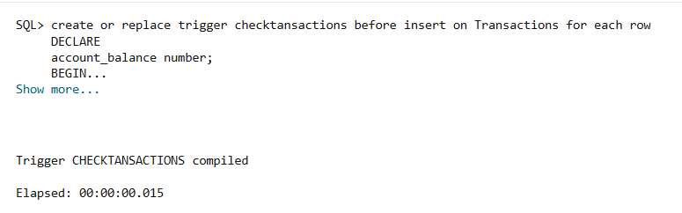**EXERCISE 6**

**SCENARIO 1**

Declare

  cursor transcation_cursor is

    select a.CustomerID,

           t.TransactionID,

           t.TransactionDate,

           t.Amount,

           t.TransactionType

      from TRANSACTIONS t

      join ACCOUNTS a

        on t.ACCOUNTID = a.ACCOUNTID

     where trunc(t.TRANSACTIONDATE,'MM') = trunc(sysdate,'MM');

  transaction_record transcation_cursor%ROWTYPE;

BEGIN

  open transcation_cursor;

  loop

    fetch transcation_cursor into transaction_record;

    exit when transcation_cursor%notfound;

    DBMS_OUTPUT.PUT_LINE(

      'CUSTOMER ID'|| transaction_record.CustomerID ||

      ' transcation id'|| transaction_record.TransactionID ||

      ' date'|| transaction_record.TransactionDate ||

      ' type '|| transaction_record.TransactionType ||

      ' amount'||transaction_record.Amount

    );

  end loop;

  close transcation_cursor;

END;

/

**OUTPUT**

**SCENARIO 2**

DECLARE

cursor annual_fee is select accountid,BALANCE from accounts;

accounts_recods annual_fee%rowtype;

fee CONSTANT number:=100;

begin

    open annual_fee;

    loop fetch annual_fee into accounts_recods;

    exit when annual_fee%notfound;

    update accounts set balance =accounts_recods.balance-fee where

    accountid=accounts_recods.accountid;

    dbms_output.put_line('deduced '|| fee||'from account'||accounts_recods.accountid||'with a new balance of'||accounts_recods.balance);

    end loop;

    close annual_fee;

    end;

    /

**OUTPUT**

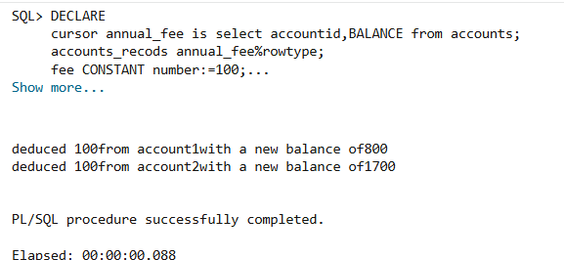

**SCENARIO 3**

declare

  CURSOR loan_intrest is

    select loanid, INTERESTRATE from loans;

  loan_rec loan_intrest%rowtype;

  new_rate number;

begin

  open loan_intrest;

  loop

    fetch loan_intrest into loan_rec;

    exit when loan_intrest%notfound;

    if loan_rec.interestrate < 10 then

      new_rate := loan_rec.interestrate + 0.5;

    else

      new_rate := loan_rec.interestrate + 0.2;

    end if;

    update loans

       set INTERESTRATE = new_rate

     where loanid = loan_rec.loanid;

    dbms_output.put_line(

      'loan id :' || loan_rec.loanid || ' has updated to ' || new_rate

    );

  end loop;

  CLOSE loan_intrest;

end;

/

**OUTPUT**

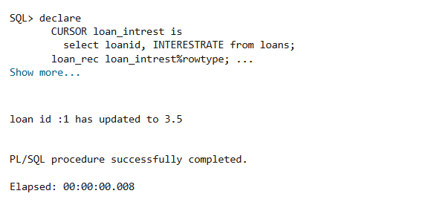

**EXERCISE 7**

**SCENARIO 1**

create or replace PACKAGE customermangement as type customer_record is RECORD(

    customer_row customers%rowtype

);

PROCEDURE addcustomer( person_record in customer_record);

PROCEDURE updatecustomer( person_record in customer_record);

FUNCTION getbalance(person_id in number) return number;

end customermangement;

/

CREATE OR REPLACE PACKAGE BODY customermangement AS

  PROCEDURE addcustomer(person_record IN customer_record) IS

  BEGIN

    INSERT INTO CUSTOMERS(CUSTOMERID, name, DOB, balance, LASTMODIFIED)

    VALUES (

      person_record.customer_row.CUSTOMERID,person_record.customer_row.name,person_record.customer_row.dob,person_record.customer_row.balance,SYSDATE

    );

  END addcustomer;

  PROCEDURE updatecustomer(person_record IN customer_record) IS

  BEGIN

    UPDATE CUSTOMERS

       SET name = person_record.customer_row.name,

           dob = person_record.customer_row.dob,

           balance = person_record.customer_row.balance,

           LASTMODIFIED = SYSDATE

     WHERE customerid = person_record.customer_row.CUSTOMERID;

  END updatecustomer;

  FUNCTION getbalance(person_id IN NUMBER) RETURN NUMBER IS

    v_balance NUMBER;

  BEGIN

    SELECT balance INTO v_balance

      FROM CUSTOMERS

     WHERE CUSTOMERID = person_id;

    RETURN v_balance;

  EXCEPTION

    WHEN NO_DATA_FOUND THEN

      dbms_output.put_line('no data found');

      RETURN NULL;

  END getbalance;

END customermangement;

/

**OUTPUT**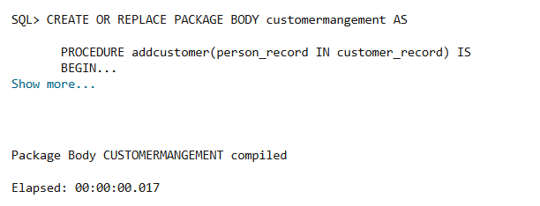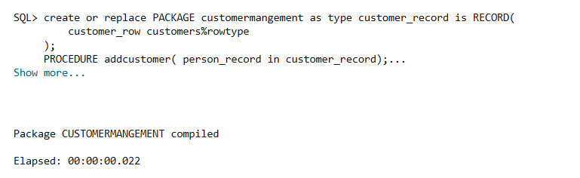

**SCENARIO 2**

CREATE OR REPLACE PACKAGE EmployeeManagement AS

  TYPE EmployeeRec IS RECORD (

    employee_row Employees%ROWTYPE

  );

  PROCEDURE HireEmployee(p_rec IN EmployeeRec);

  PROCEDURE UpdateEmployee(p_rec IN EmployeeRec);

  FUNCTION GetAnnualSalary(p_employeeid IN NUMBER) RETURN NUMBER;

END EmployeeManagement;

/

CREATE OR REPLACE PACKAGE BODY EmployeeManagement AS

  PROCEDURE HireEmployee(p_rec IN EmployeeRec) IS

  BEGIN

    INSERT INTO Employees

      (EmployeeID, Name, Position, Salary, Department, HireDate)

    VALUES

      (p_rec.employee_row.EmployeeID,p_rec.employee_row.Name,p_rec.employee_row.Position,p_rec.employee_row.Salary,p_rec.employee_row.Department,SYSDATE);

  END HireEmployee;

  PROCEDURE UpdateEmployee(p_rec IN EmployeeRec) IS

  BEGIN

    UPDATE Employees

       SET Name= p_rec.employee_row.Name,Position= p_rec.employee_row.Position,Salary= p_rec.employee_row.Salary,Department = p_rec.employee_row.Department

     WHERE EmployeeID = p_rec.employee_row.EmployeeID;

  END UpdateEmployee;

  FUNCTION GetAnnualSalary(p_employeeid IN NUMBER) RETURN NUMBER IS

    v_salary NUMBER;

  BEGIN

    SELECT Salary INTO v_salary FROM Employees

     WHERE EmployeeID = p_employeeid;

    RETURN v_salary * 12;

  EXCEPTION

    WHEN NO_DATA_FOUND THEN

      RETURN NULL;

  END GetAnnualSalary;

END EmployeeManagement;

/

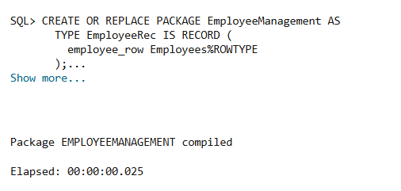**OUTPUT**

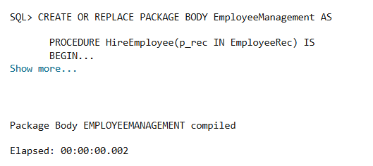

**SCENARIO 3**

  CREATE OR REPLACE PACKAGE AccountOperations AS

  TYPE AccountRec IS RECORD (

    acct_row Accounts%ROWTYPE

  );

  PROCEDURE OpenAccount(p_rec IN AccountRec);

  PROCEDURE CloseAccount(p_accountid IN NUMBER);

  FUNCTION GetTotalBalance(p_customerid IN NUMBER) RETURN NUMBER;

END AccountOperations;

/

CREATE OR REPLACE PACKAGE BODY AccountOperations AS

  PROCEDURE OpenAccount(p_rec IN AccountRec) IS

  BEGIN

    INSERT INTO Accounts

      (AccountID, CustomerID, AccountType, Balance, LastModified)

    VALUES

      (p_rec.acct_row.AccountID,p_rec.acct_row.CustomerID,p_rec.acct_row.AccountType,p_rec.acct_row.Balance,SYSDATE);

  END OpenAccount;

  PROCEDURE CloseAccount(p_accountid IN NUMBER) IS

  BEGIN

    DELETE FROM Accounts WHERE AccountID = p_accountid;

  END CloseAccount;

  FUNCTION GetTotalBalance(p_customerid IN NUMBER) RETURN NUMBER IS

    v_total NUMBER;

  BEGIN

    SELECT COALESCE(SUM(Balance), 0)

      INTO v_total

      FROM Accounts

     WHERE CustomerID = p_customerid;

    RETURN v_total;

  END GetTotalBalance;

END AccountOperations;

/

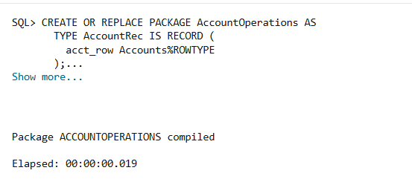**OUTPUT**

